[re to see more](https://www.thetimes.co.uk/article/beware-greedy-giants-mbbmr9hxc)

[Dismiss](https://www.thetimes.co.uk/article/beware-greedy-giants-mbbmr9hxc)

**Accessibility Links**

[Skip to content](https://www.thetimes.co.uk/article/beware-greedy-giants-mbbmr9hxc#main-container)

[times logo](https://www.thetimes.co.uk/)

Top of Form

Search The Times and The Sunday Times

Bottom of Form

[Today’s sections](https://www.thetimes.co.uk/)[Past six days](https://www.thetimes.co.uk/past-six-days)[My articles](https://www.thetimes.co.uk/my-articles)

[Times+](https://www.mytimesplus.co.uk/)

[My account](https://home.thetimes.co.uk/)

STEVE PARISH

may 19 2019, 12:01am, the sunday times

Beware of rich giants in European power struggle

**steve parish**

Europe’s biggest clubs don’t want teams such as Spurs to gatecrash their party

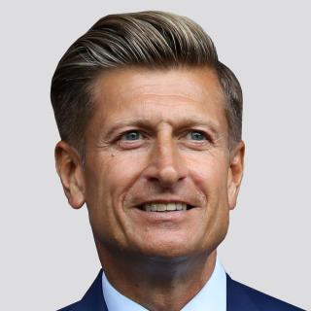

Share

Save

Like everyone who loves football, I relished Liverpool 4 Barcelona 0 and Ajax 2 Tottenham 3 — the greatest week the Champions League has produced. It was encapsulated in an emotional interview with Mauricio Pochettino at the end of Spurs’ game in Amsterdam. You would have to be made of stone, or an Arsenal fan, not to feel the unbridled joy of a man and team who have worked tirelessly to compete at the highest level.

What were those semi-finals about? Daring, risk, jeopardy. Outcomes that hung in the balance until the final seconds and then reverberated around the world when the final whistle blew — elements that are the very essence of competitive sport. Well, enjoy it while it lasts — because there are plans afoot from a small group of clubs to take that away.

They want “stability”, not risk. They want rewards for “history”, not growing and developing. They certainly do not want newcomers like Spurs — in their first Champions League final — gatecrashing their party. It is a threat that should worry everyone, and one that must be resisted.

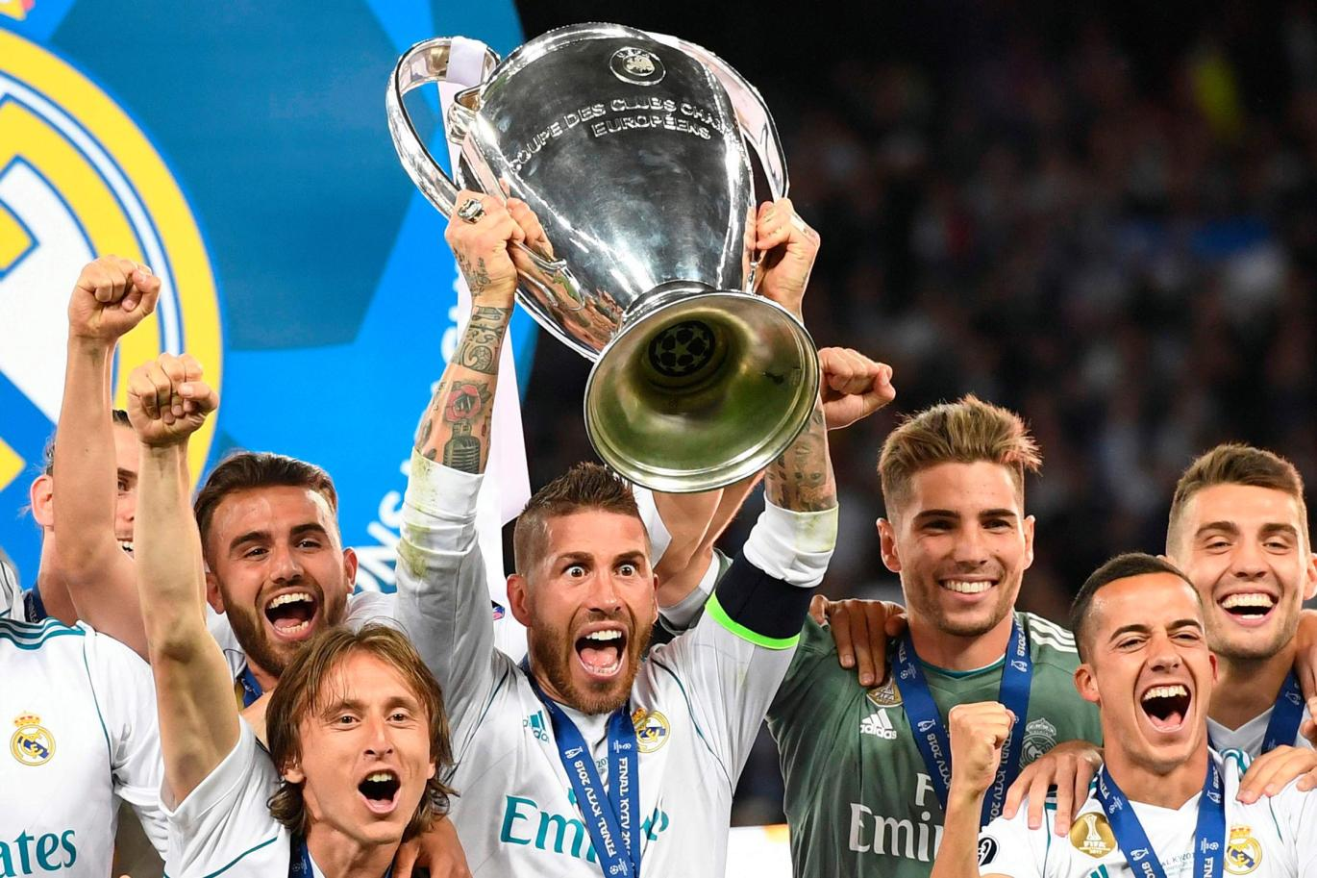

Status quo: Real Madrid lifted a fourth European Cup in five years last summer and that dominance would likely increase under new plansPAUL ELLIS

We all know the narrative that haunted Spurs for years: decent players, soft team, never really challenged for the league but might win a cup. That changed when Daniel Levy took over. With hard work and acumen and the sensible backing of Joe Lewis, the club has been transformed to one with arguably the smartest transfer policy in football (do not spend any money at all; just make what you have better), the best youth system, probably the best training ground and now the world’s best stadium.

It is the stuff every fan dreams of happening to their club. From Barcelona to Bournemouth, we are all part of one meritocracy — a pyramid of domestic leagues featuring thousands of clubs, each one representing a community and the dream of local people that, no matter how remote the possibility, their club might one day rise up and reach the apex — European competition.

Last week European Leagues, the association of European professional football leagues, hosted its annual get-together in Madrid. It was an amazing two days, involving 244 clubs from 38 countries. Among those present was Dariusz Mioduski, owner of Legia Warsaw, regular champions of Poland — a country of almost 40 million, which does not get an automatic qualifying spot for the Champions League. Instead they have to pre-qualify, starting in the summer when their top players are exhausted, without a proper break after international duty. Typically, they do not make it, and fall into the Europa League where it is hard for Dariusz to make his team profitable.

I met Darek [Jakubowicz], desperately fighting relegation with his team, Bohemians Praha 1905, in Czech Republic and the charming and amusing Aurelio [Andreazzoli], manager of Empoli, who has two games to retain Serie A status. And so it went on ... I was surrounded by people who loved the game, their town and club, for whom football brings little glory and mostly uncertainty. What keeps us all going is the dream that one day we might just find the way, like Spurs, to grow and challenge. There was another attendee, who also sits on the board of the ECA (European Club Association). The ECA was born from a group called G-14 who in the 1990s wanted to create a European Super League. This gang of “big” clubs are unhappy with lots of things and whilst essentially being a pressure group, have become integrated into some key decision-making areas of Uefa. The Uefa game board, comprised of 18 people, decides how European competitions work — and how the money is distributed. It is made up of four Uefa officials, 13 representatives of ECA and one person from European Leagues. Yes, that’s right: just one individual representing all the other clubs in Europe, more than 1,000 of them.

The ECA has a massive impact. When Sepp Blatter and Michel Platini fell from grace circa 2015 it created a power vacuum and in the ECA jumped. Qualifying was moved away from solely merit and the concept of “history” introduced, virtually guaranteeing places for certain countries and not others.

At the end of a long session, questions were invited and microphones passed around, everyone dutifully waiting their turn — except our ECA attendee, who somewhat symbolically eschewed the microphone and instead walked to the podium to make the following “speech”. He explained his club developed a lot of young players but one year they are in Champions League, the next the Europa and for two years did not manage to qualify at all. His solution was that the rules need to be changed so his team always qualifies because they “must” have stability. I kid you not, in a room full of instability, worry, risk and jeopardy, this guy wanted to be a special case forever.

Here’s the ECA’s latest plan for the Champions League. “History” will become an even bigger part of qualifying, to the point where the only way any club outside the established English elite would qualify for the first year of this new system (in 2024) would be to win the Premier League. Thereafter the top 24 teams in the Champions League would qualify for the next year’s tournament. Four places would go to teams “promoted” from a second-tier European league, and just four to sides based on performances within their national league. So: no more rising up. No more Tottenhams.

The ECA wants a Champions League group stage where teams play 14 games instead of six. They envisage they can grab €2bn of media value from domestic leagues, see the Premier League reduced to 18 teams, have 15% of professional footballers paid infinitely more and 85% much less, and ask fans to travel all over Europe for often dead rubbers instead of enjoying their traditional, local rivalries. This plan would ruin the professional game and have a knock-on effect upon the grass roots, but at least our friend at the podium would have less anxiety, and the big clubs more money, and the Ferrari dealers of Milan and Madrid — thanks to further enriched star footballers — would become the envy of their peers.

The Premier League clubs, including the Big Six, to their credit passed a unanimous motion opposing such changes. There was a barnstorming address by Javier Tebas, who made his pitch not in his capacity as president of La Liga, but as former owner of a Spanish second division club. He understood the struggles most of football faces and the power grab the ECA plans may represent. We cannot be complacent: 2024 may seem far off but decisions about the Champions League future will be made in the next 18 months. As Tebas understood, if, like in 2016, we are asleep at the wheel and do not get organised, the ECA will win and the game in Europe will be poorer and unrecognisable. Everyone in Madrid accepted the need for change and progress, but it must be driven by the wider club constituency.

I never underestimate the propensity of people to ruin a good thing. Amid football’s greatest week, I was confronted by what I believe to be its greatest threat for decades. Lars-Christer Olsson, president of European Leagues, did not pull his punches when he said that right now the clubs and Uefa are heading for a war. I hope that can be avoided.

*Steve Parish is the part-owner and chairman of Crystal Palace FC*